SmartHealth Customized Activity Request Form
Guidelines
Submit your request at least 30 days ahead of your desired launch date.
Instructions
- Enter your information below (or print, fill out, and scan)
- Email this form to: customactivityrequest@limeade.com
- Limeade works with you to get request approved.
- You will hear from us as soon as possible to begin promoting your custom SmartHealth activity.
Limeade works with you to get request approved. You will hear from us as soon as possible to begin promotion.
Enter your details (Click and type enter text)
ORGANIZATION: | Choose an item.
NAME: | Click here to enter text.
PHONE: | Click here to enter text.
EMAIL: | Click here to enter text.

Enter activity details (Click and type here to enter text)
See the screenshot example on the next page to help fill out the following details.
TITLE: | What is the title of your Activity? 50 characters max.
POINTS: | How many points would you like this Activity to be worth?.
TRACKING DETAILS: | From the dropdown menu, choose how you would like people to track the Activity and earn points, e.g.: hit a goal every week? hit the goal at the end of the period? do something one time?
ACTIVITY REQUIREMENT: | 50 characters max - what needs to be done to complete the Activity, e.g.: walk 40,000 steps/week; avoid processed foods 5 times this week, etc.?
DEVICE-ENABLED: | Do you want to use a device to track this activity, e.g.: a fitbit, mapmyrun, etc?.
DATES: | What dates do you want this to begin and end, e.g.: 5/1/2016 - 9/30/2016?
SHORT DESCRIPTION: | Enter a short description of the Activity. Must be 300 characters or less. Try to make this short, interesting, and include the important details. For best results, include a call to action!
LONG DESCRIPTION: | Enter a long description of no more than 2000 characters. Use this space to add more detail, provide context, include links, resources, or tips. Make sure to provide all the information needed to complete the Activity.
IMAGE: | Enter a description of the image you would like to display. Or, if you have the image you want to use, just attach it to the email.

***See the following page for a screenshot outlining all of the components requested***

Screenshot Diagram

Example of a finished activity, diagraming how the fields above fit with a finished activity

Title
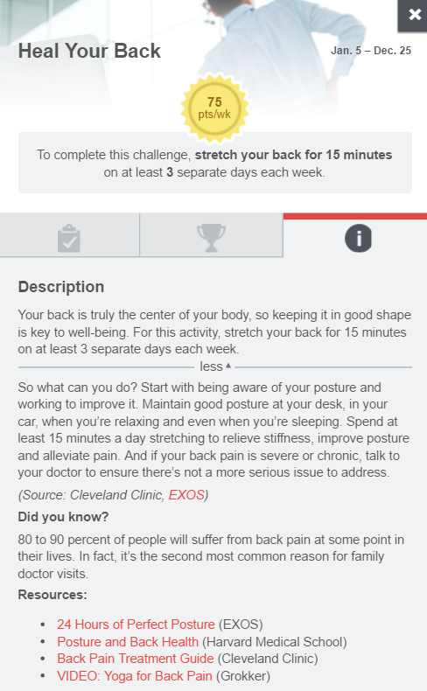

Long description
Short description
Points
Dates

Tracking details and activity requirement

