Subject: Celebrate 2018 SmartHealth Week – Acts of Kindness

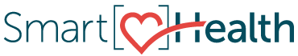
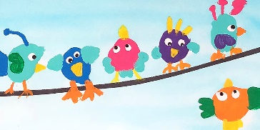
Celebrate!
Sign in to SmartHealth to join us for 2018 SmartHealth Week – Acts of Kindness.

During SmartHealth Week, employees from across Washington State will come together to build community connections by performing Acts of Kindness.
Kindness matters. Whether you have 5 minutes or 5 hours, show someone you care. Acts of kindness range from smiling at strangers, donating to food banks, or paying for someone’s coffee. The definition of kindness is “the quality of being friendly, generous, and considerate”. When we focus on kindness during SmartHealth Week, we can support each other, and make a difference at work, at home, and in our communities. Start small – and then make Acts of Kindness part of every day.
Join the individual activity, the team activity, or BOTH!
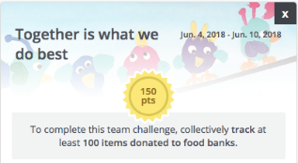
Team Activity:
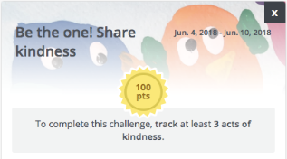
Together is what we do best – donate to a food bank (earn 150 SmartHealth points)
Individual Activity:
Be the one! Share kindness. (earn 100 SmartHealth points)
SmartHealth Week gives us a chance to leave the world better than we found it and inspire others to do the same.
Be well,

Your SmartHealth Team
Supporting you on your journey toward living well

