Managing Stress in Difficult Times Message (SEBB)

How to use
- Share the message below to promote the Managing Stress in Difficult Times activity, which runs from February 15 to April 2, 2021.
- The message is ready to use as is or you can edit to make it work for your organization.
- If needed, finish by adding your contact information, logo, and more.

Tip: Highlight the value of worksite wellness by getting leadership to send the message. Doing this completes tasks 1.3 and 5.4 of our SmartHealth Worksite Wellness Roadmap to earn our Zo8 Award.
MESSAGE BELOW

Email Subject: Support your mental health
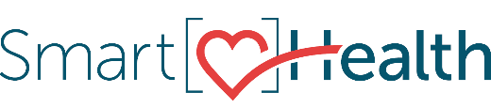
The COVID-19 pandemic has changed the lives of billions of people in a very short amount of time. As a result, many people are struggling with fear, anger, and incredible levels of stress. Even when times are difficult, you can still be empowered to support your mental health.

Build coping skills in stressful times
These are unusual times, and it’s okay that things don’t feel normal. Here are some things to try if you’re feeling this way.

- Stay in touch through phone calls, email, and online chats.
- Focus on things within your control.
- Find a few minutes to take care of yourself and do something that is meaningful to you.

Join the Managing Stress in Difficult Times activity in SmartHealth to learn more ways to manage stress.

Additional support
If you are still struggling, please call a mental health specialist who can help you with the resources you need. You are not in this alone. It’s okay to ask for help.

What is SmartHealth?
SmartHealth is included in your benefits and is a voluntary wellness program that supports your whole person well-being. It helps you manage stress, build resiliency, and adapt to change. As you progress on your wellness journey, you can qualify for the SmartHealth wellness incentives.

Be well,

The SmartHealth Team
Supporting you on your journey toward living well

MESSAGE END

