Want to Live Longer? Get Enough Sleep – Message (PEBB)

How to use
- Share the message below to promote the Want to Live Longer? Get Enough Sleep activity, which runs from May 10 to July 2, 2021.
- The message is ready to use as is or you can edit to make it work for your organization.
- If needed, finish by adding your contact information, logo, and more.

Tip: Highlight the value of worksite wellness by getting leadership to send the message. Doing this completes tasks 1.3 and 5.4 of our SmartHealth Worksite Wellness Roadmap to earn our Zo8 Award.

MESSAGE BELOW

Email subject: Want to live longer? Get enough sleep
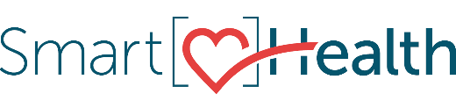
We have so many demands on our time—jobs, family, errands—not to mention finding some time to relax. To fit everything in, we often sacrifice sleep.

Why sleep matters
Sleep affects both mental and physical health. It’s vital for learning and memory, and lack of sleep affects our health, safety, and longevity.

What are the benefits of sleep?
- Boosts your immune system
- Strengthens your heart
- Better sleep = better mood

Tips for getting more sleep
- Be consistent with the time you go to bed and wake up, even on the weekends.
- Set an alarm clock for bedtime, just as you set it for wake-up time.
- Remove electronic devices, such as TVs, computers, and smart phones, from the bedroom.

Want more?
Join the "Want to live longer? Get enough sleep” activity from May 10 to July 2 in SmartHealth.

Good sleep is critical to your health. To make each day a safe, productive one, take steps to make sure you regularly get a good night’s sleep.

What is SmartHealth?
SmartHealth is included in your benefits and is a voluntary wellness program that supports your whole person well-being. It helps you manage stress, build resiliency, and adapt to change. As you progress on your wellness journey, you can qualify for the SmartHealth wellness incentives.

Be well,
The SmartHealth Team
Supporting you on your journey toward living well

