Want to Live Longer? Get Enough Sleep – Article (PEBB)

How to use
- Share the article below in a newsletter or blog to promote the Want to Live Longer? Get Enough Sleep activity, which runs from May 10 to July 2, 2021.
- The article is ready to use as is or you can edit to make it work for your organization.
- If needed, finish by adding your contact information, logo, and more.

ARTICLE BELOW

Title: Want to live longer? Get enough sleep
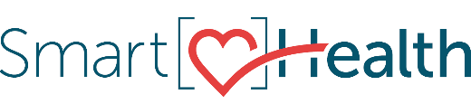
We have so many demands on our time—jobs, family, errands—not to mention finding some time to relax. To fit everything in, we often sacrifice sleep.

Why sleep matters
Sleep affects both mental and physical health. It’s vital for learning and memory, and lack of sleep affects our health, safety, and longevity.

What are the benefits of sleep?
- Boosts your immune system
- Strengthens your heart
- Better sleep = better mood

Sleep disruptions
Sleep can be disrupted by many things. Stimulants such as caffeine or certain medications can keep you up. Distractions such as electronics—especially the light from TVs, cell phones, tablets, and e-readers—can prevent you from falling asleep.

Tips for getting more sleep
- Make sure your bedroom is quiet, dark, relaxing, and at a cool temperature.
- Get some exercise during the day.
- Get it off your mind. Research showed people who spent 5 minutes jotting down a list of upcoming tasks drifted off to sleep 9 minutes quicker.

Want more?
Join the "Want to live longer? Get enough sleep” activity from May 10 to July 2 in SmartHealth.

Good sleep is critical to your health. To make each day a safe, productive one, take steps to make sure you regularly get a good night’s sleep.

What is SmartHealth?
SmartHealth is included in your benefits and is a voluntary wellness program that supports your whole person well-being. It helps you manage stress, build resiliency, and adapt to change. As you progress on your wellness journey, you can qualify for the SmartHealth wellness incentives.

