Practicing Mindful Eating – Message (PEBB)

How to use
- Share the message below to promote the Practicing Mindful Eating activity, which runs from May 10 to July 2, 2021.
- The message is ready to use as is or you can edit to make it work for your organization.
- If needed, finish by adding your contact information, logo, and more.

Tip: Highlight the value of worksite wellness by getting leadership to send the message. Doing this completes tasks 1.3 and 5.4 of our SmartHealth Worksite Wellness Roadmap to earn our Zo8 Award.

MESSAGE BELOW

Email Subject: Be mindful about your eating
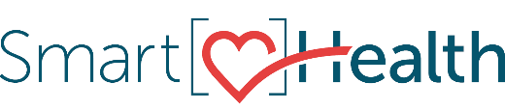
Eating can become a mindless act, often done quickly. This can be problematic since it takes your brain up to 20 minutes to realize you’re full.

By eating mindfully, you restore your attention and slow down, making eating an intentional act instead of an automatic one.

What is mindful eating?
Mindful eating is practicing awareness and focus while preparing and consuming food.

It invites us to remove distractions and sit uninterrupted with our food. In doing so, we begin to slow down, savor the flavors, and notice when we are full.

Limit distractions
When was the last time you paid attention to your eating? Many of us often eat on autopilot, chowing down food while our attention is on the TV, a book, a conversation, or lost in a daydream.

Try it!
Join the “Practicing Mindful Eating” activity in SmartHealth between May 10 and July 2. Bring awareness to what you’re eating, why you’re eating, and how you typically consume food. Mindful eating takes practice.

What is SmartHealth?
SmartHealth is included in your benefits and is a voluntary wellness program that supports your whole person well-being. It helps you manage stress, build resiliency, and adapt to change. As you progress on your wellness journey, you can qualify for the SmartHealth wellness incentives.

Be well,
The SmartHealth Team
Supporting you on your journey toward living well

