How to Live a Life with Meaning Message (PEBB)

How to use
- Share the message below to promote the How to Live a Life with Meaning activity, which runs from January 4 to April 2, 2021.
- The message is ready to use as is or you can edit to make it work for your organization.
- If needed, finish by adding your contact information, logo, and more.

Tip: Highlight the value of worksite wellness by getting leadership to send the message. Doing this completes tasks 1.3 and 5.4 of our SmartHealth Worksite Wellness Roadmap to earn our Zo8 Award.
MESSAGE BELOW

Email Subject: What gives your life meaning?
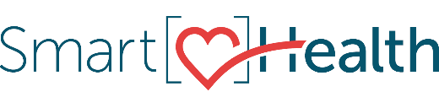
You have a purpose–the reason you get up in the morning You also have unique gifts to share. And finding out how to do that is achievable and worth achieving. Knowing your purpose can give you a sense of direction and create meaning in your life. It motivates you to do and be your best.

Adapt to changes
Your purpose can shift in response to the changes you experience throughout life. We all experience bumps in the road. It’s natural to hit challenges and times of confusion along the way. Many people find themselves on a path in life that isn’t quite what they expected. Where did you assume your life would be at this stage in your story? How is it different from reality? How would you like the story to evolve from here?

Find your purpose
We continue to grow and be engaged late into life. It’s your story that truly matters.
Join the How to Live a Life with Meaning activity in SmartHealth to explore your purpose more.

What is SmartHealth?
SmartHealth is included in your benefits and is a voluntary wellness program that supports your whole person well-being. It helps you manage stress, build resiliency, and adapt to change. As you progress on your wellness journey, you can qualify for the SmartHealth wellness incentives.

Be well,

The SmartHealth Team
Supporting you on your journey toward living well

MESSAGE END

