May is Mental Health Month – Message (SEBB)

How to use
- Share the message below to promote the May is Mental Health Month activity, which runs from May 1 through 31, 2021.
- The message is ready to use as is or you can edit to make it work for your organization.
- If needed, finish by adding your contact information, logo, and more.

Tip: Highlight the value of worksite wellness by getting leadership to send the message. Doing this completes tasks 1.3 and 5.4 of our SmartHealth Worksite Wellness Roadmap to earn our Zo8 Award.

MESSAGE BELOW

Email subject: Your mental health matters
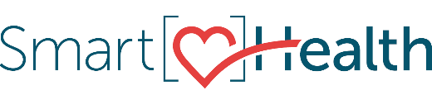
May is mental health month, and now more than ever it’s important to focus on developing mental health habits like creating healthy routines, connecting with others, and seeking help when you need it.

What is mental health?
Mental health includes our emotional, psychological, and social well-being. It affects how we think, feel, and act. It also helps us determine how we handle stress, relate to others, and make healthy choices.

How does mental health affect me?
We all want to feel well, both mentally and physically. But what feeling well means, especially in terms of mental health, varies for each of us. We all need different things to feel our best, but for all of us it’s
about feeling positive about ourselves and others, being able to form good relationships, and having the resilience to overcome challenges.

How can I help my mental health?
No one should feel alone or without the support they need. Staying connected to others and your community, and making time for things you enjoy, can help your mental well-being. For more information and links to resources, join the “May is Mental Health Month” activity from May 1 to 31 in SmartHealth.

What is SmartHealth?
SmartHealth is included in your benefits and is a voluntary wellness program that supports your whole person well-being. It helps you manage stress, build resiliency, and adapt to change. As you progress on your wellness journey, you can qualify for the SmartHealth wellness incentives.

Be well,

The SmartHealth Team
Supporting you on your journey toward living well

