The Importance of Goal Setting Message (PEBB)

How to use
- Share the message below to promote the Importance of Goal Setting activity, which runs from January 4 to April 2, 2021.
- The message is ready to use as is or you can edit to make it work for your organization.
- If needed, finish by adding your contact information, logo, and more.

Tip: Highlight the value of worksite wellness by getting leadership to send the message. Doing this completes tasks 1.3 and 5.4 of our SmartHealth Worksite Wellness Roadmap to earn our Zo8 Award.
MESSAGE BELOW

Email Subject: Dream it. Believe it. Achieve it.
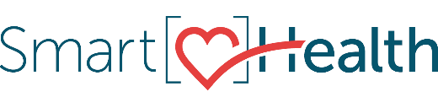
Goals are the first step toward planning for the future. They play a fundamental role in developing skills throughout various phases of life, from work to relationships and everything in between. Without a goal, we would go through life not knowing which way to go.

What is goal setting?
Goal setting is a process of deciding what we want to achieve over a particular period.
Setting goals is linked to self-confidence, motivation, and independence.

Why should I care about goal setting?
Goals give us focus, help us measure progress, and help us stay motivated.

How can I get started?
Join the Importance of Goal Setting activity in SmartHealth.

What is SmartHealth?
SmartHealth is included in your benefits and is a voluntary wellness program that supports your whole person well-being. It helps you manage stress, build resiliency, and adapt to change. As you progress on your wellness journey, you can qualify for the SmartHealth wellness incentives.

Be well,

The SmartHealth Team
Supporting you on your journey toward living well

MESSAGE END

