The Importance of Goal Setting Article (SEBB)

How to use
- Share the article below in a newsletter or blog to promote The Importance of Goal Setting activity, which runs from January 4 to April 2, 2021.
- The article is ready to use as is or you can edit to make it work for your organization.
- If needed, finish by adding your contact information, logo, and more.

ARTICLE BELOW

Title: Dream it. Believe it. Achieve it.
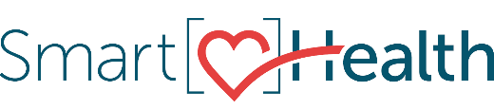
Goals are the first step toward planning for the future. They play a fundamental role in developing skills throughout various phases of life, from work to relationships and everything in between. Without a goal, we would go through life not knowing which way to go.

What is goal setting?
Goal setting is a process of deciding what we want to achieve over a particular period.
Setting goals is linked to self-confidence, motivation, and independence.

Why should I care about goal setting?
Goals affect the intensity of our actions and our emotions – the more difficult and valued a goal is, the more intense our efforts will be to attain it, and the more success we experience following achievement. Goals give us focus, help us measure progress, and help us stay motivated.

How do I write goals?
Goal setting is simple. It doesn’t take much time and can become a habit that creates calm. A goal helps you clarify what you truly desire, and it creates excitement.

Start by identifying what you want and why you want it. You may have short-term goals like eating healthier, medium-term goals like finding a life partner, and longer-term goals like having a rewarding career. Set a monthly goal, weekly goals, and daily goals to keep you moving toward your desired outcomes.

How can I get started?
Join the Importance of Goal Setting activity in SmartHealth.

What is SmartHealth?
SmartHealth is included in your benefits and is a voluntary wellness program that supports your whole person well-being. It helps you manage stress, build resiliency, and adapt to change. As you progress on your wellness journey, you can qualify for the SmartHealth wellness incentives.

ARTICLE END

