Give a little, help a lot Message (SEBB)

How to use
- Share the message below to promote the Give a little, help a lot activity, which runs from October 1 to November 30, 2021.
- The message is ready to use as is or you can edit to make it work for your organization.
- If needed, finish by adding your contact information, logo, and more.
Tip: Highlight the value of worksite wellness by getting leadership to send the message. Doing this completes tasks 1.3 and 5.4 of our SmartHealth Worksite Wellness Roadmap to earn our Zo8 Award.
MESSAGE BELOW

Email Subject: Join SmartHealth's "Give a little, help a lot" event

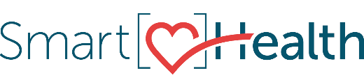

Join SmartHealth’s “Give a little, help a lot” event
When we give back and help others, we can make a difference at home, at work, and in our communities. Whether you help a neighbor, donate to an organization, volunteer your time, or simply show acts of kindness, it all matters. By giving back, we help others and ourselves.

Give back
Join the Give a little, help a lot event in SmartHealth. The event runs from October 1 through November 30, 2021. You can earn 200 SmartHealth points by participating.

Don’t miss out
You still have time to qualify for the $125 wellness incentive by completing your well-being assessment and earning 2,000 SmartHealth points by November 30, 2021. Learn more about SmartHealth for details.

What is SmartHealth?
SmartHealth is included in your benefits and is a voluntary wellness program that supports your whole person well-being. It helps you manage stress, build resiliency, and adapt to change. As you progress on your wellness journey, you can qualify for the SmartHealth wellness incentive.

Be well,
The SmartHealth Team
Supporting you on your journey toward living well

