Give a little, help a lot Article (PEBB)

How to use
- Share the article below in a newsletter or blog to promote the Give a little, help a lot activity, which runs from October 1 to November 30, 2021.
- The article is ready to use as is or you can edit to make it work for your organization.
- If needed, finish by adding your contact information, logo, and more.

ARTICLE BELOW

Title: Give a little, help a lot
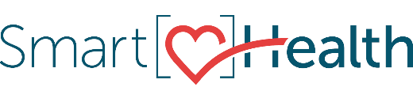
Did you know the little things you do for others will also help you, too? Helping others has been shown to be good for our mental health and well-being. It can give you a sense of purpose and make you feel happier and more satisfied about life.
When we give back and help others, we can make a difference at home, at work, and in our communities. Whether you help a neighbor, donate to an organization, volunteer your time, or simply show acts of kindness, it all matters. By giving back, we help others and ourselves.

Give back
Join the Give a little, help a lot event in SmartHealth. The event runs from October 1 through November 30, 2021. You can earn 200 SmartHealth points by participating.

Don’t miss out
You still have time to qualify for the $125 wellness incentive by completing your well-being assessment and earning 2,000 SmartHealth points by November 30, 2021. Learn more about SmartHealth for details.

What is SmartHealth?
SmartHealth is included in your benefits and is a voluntary wellness program that supports your whole person well-being. It helps you manage stress, build resiliency, and adapt to change. As you progress on your wellness journey, you can qualify for the SmartHealth wellness incentives.

