What’s Your Why Message (PEBB)

How to use
- Share the message below to promote the What’s Your Why activity, which runs from March 2 to May 1, 2020.
- The message is ready to use as is or you can edit to make it work for your organization.
- If needed, finish by adding your contact information, logo, and more.

Tip: Highlight the value of worksite wellness by getting leadership to send the message. Doing this completes tasks 1.3 and 5.4 of our SmartHealth Worksite Wellness Roadmap to earn our annual Zo8 Award.

MESSAGE BELOW

Email Subject: Join the SmartHealth What’s Your Why activity

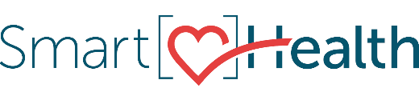
Join the SmartHealth What’s Your Why activity today. Your why is your purpose — it’s what is most important to you. Research supports the power of purpose, of knowing your why, and how it can help you live a happier, healthier, and longer life.
Your why can be something big or small, it may change over time, you might even have more than one, but it always support your beliefs and values.
Help grow our SmartHealth community as we all continue our journey toward living well.

Have fun. Earn rewards.
The most meaningful rewards might be the chance to discover your why, pursue your purpose, and be your best. In case you need another reason, SmartHealth also offers a $25 Amazon.com gift card and a $125 wellness incentive. Learn more about SmartHealth for details.

Be well,

The SmartHealth Team
Supporting you on your journey toward living well

MESSAGE END

