Commit to Successful Habits Message (SEBB)

How to use
- Share the message below to promote the Commit to Successful Habits activity, which runs from May 11 to July 3, 2020.
- The message is ready to use as is or you can edit to make it work for your organization.
- If needed, finish by adding your contact information, logo, and more.

Tip: Highlight the value of worksite wellness by getting leadership to send the message. Doing this completes tasks 1.3 and 5.4 of our SmartHealth Worksite Wellness Roadmap to earn our Zo8 Award.

MESSAGE BELOW

Email Subject: Commit to successful habits with SmartHealth

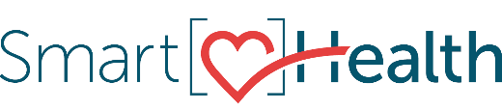
Join the SmartHealth Commit to Successful Habits activity today. Successful people aren't afraid to adapt, change or learn new habits of success from others. Learning skills of success from others, and adopting those skills into your routine, can be a great way to build success in your own life.

Make time for you
SmartHealth makes it easier to add healthy activities into your busy schedule. Whether you are trying something new or adding to what you already do, it has something from everyone. You could also qualify for a $125 wellness incentive each year!

Share the news
Even if you waived SEBB medical benefits, you can use SmartHealth! Although you are not eligible to qualify for the $125, you can join in on the fun and support your journey toward living well. Learn more about SmartHealth for details.
Be well,

The SmartHealth Team
Supporting you on your journey toward living well

MESSAGE END

