Governor’s Virtual SmartHealth Walk Message (SEBB)

How to use
- Share the message below to promote the Governor’s Virtual SmartHealth Walk event, which runs from August 24-September 1, 2020.
- The message is ready to use as is or you can edit to make it work for your organization.
- If needed, finish by adding your contact information, logo, and more.

Tip: Highlight the value of worksite wellness by getting leadership to send the message. Doing this completes tasks 1.3 and 5.4 of our SmartHealth Worksite Wellness Roadmap to earn our annual Zo8 Award.
MESSAGE BELOW

Email Subject: Walk with Governor Jay Inslee virtually in SmartHealth

Join us for a virtual walk with Governor Jay Inslee to celebrate your well-being. Governor Inslee encourages you to get in on the fun to boost your physical and mental well-being.

While we are unable to gather and walk in-person this year, you can still walk anywhere, anytime between August 24 and September 1.

After your walk, make sure you:
- Sign in to SmartHealth.
- Join the Governor’s Virtual SmartHealth Walk activity and track your walk to earn 200 points.
- Share photos of your walk on the SmartHealth community feed.

Learn more about SmartHealth.

Be well,

Your SmartHealth Team
Supporting you on your journey toward living well
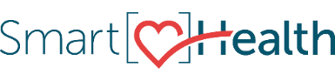

MESSAGE END

