Generation Wellness Message (SEBB)

How to use
- Share the message below to your staff.
- The message is ready to use as is or you can edit to make it work for your organization.
- If needed, finish by adding your contact information, logo, and more.

Tip: Highlight the value of worksite wellness by getting leadership to send the message. Doing this completes tasks 1.3 and 5.4 of our SmartHealth Worksite Wellness Roadmap to earn our annual Zo8 Award.

MESSAGE BELOW

Email Subject: Experience simple tools for less stress and more success

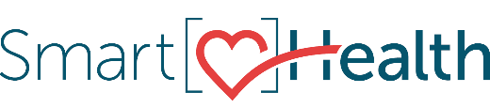
SmartHealth has partnered with Generation Wellness to offer free trainings and videos designed to promote wellness, enhance your well-being and help you live your best life.

Generation Wellness founder Lyndsay Morris teaches simple practices that strengthen heart, mind, and body resulting in deeper connection to self and with others. The end goal: Happy, healthy, whole people who have the necessary skills to cope with stress and thrive in life. This is why SmartHealth partnered with them to offer you free trainings (both in-person and online) and monthly videos!
Just sign in to SmartHealth to watch these exclusive videos that dive into a new well-being theme each month such as gratitude, mindful eating, and communication.
The free in-person trainings offer simple tools based on neuroscience proven to increase happiness, decrease stress, and increase productivity. Learn how you can sign up for a Wellness in the Workplace training. You can learn about the online trainings starting in April.

What is SmartHealth?
SmartHealth is a fun, secure, and easy-to-use website that supports you on your journey toward living well. As you progress on your journey, you could qualify for a $125 wellness incentive. Learn more about SmartHealth for details.
Be well,

The SmartHealth Team
Supporting you on your journey toward living well

MESSAGE END

