

EMAIL COPY
Q4 CAMPAIGN 2026

The copy below is useful for employee emails, employee newsletters, and other company channels. The copy is also useful if introducing and supplementing the flyer and/or banner.
—--------------------------------------------------------------------------------------------------------------------------

Title/Subject Line: A health coach in your corner
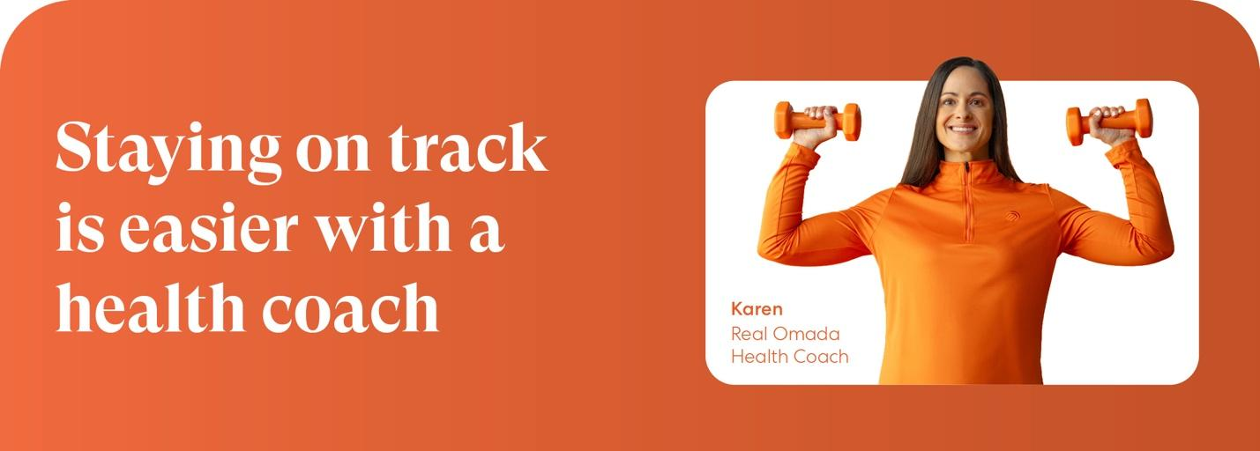

The right support can make all the difference. The PEBB Program offers Omada® for Prevention & Weight Health, a virtual program that combines personalized coaching and AI-powered tools to help you stay consistent and build healthier habits over time.

The best part? It’s fully covered by your medical plan, if eligible.

Support that helps you stay consistent

- Health coach
Get tailored guidance around nutrition, exercise, sleep and stress.

- AI-powered insights
In-the-moment tips that help you keep moving toward your goals.

- Connected smart scale
Shipped to your door to help you track progress.

- Dynamic food tracking
A new tool that can help you make healthier food choices.

Check if you’re eligible.
If you or your adult family members are at risk for type 2 diabetes, your PEBB medical plan will cover the entire cost of the program.
The PEBB diabetes prevention program, called Omada for Prevention and Weight Health, is available to PEBB members enrolled in any non-Medicare medical plan. Omada also offers a diabetes management program for PEBB members enrolled in Uniform Medical Plan (UMP). To learn more about these programs, visit Diabetes programs.

