Diabetes Prevention Program Messages
Use one or all of the messages below to promote the Diabetes Prevention Program (DPP) to your staff. We have four messages to choose from, each with their own look and feel.

How to use
- Share the message(s) below to promote DPP.
- The message is ready to use as is or you can edit it to make it work for you.
- Finish by adding your contact information, logo, and more.

Tip: Highlight the value of wellness at your worksite by getting leadership to send one of these DPP messages. Doing this completes tasks 1.3 and 5.4 of our SmartHealth Worksite Wellness Roadmap to earn our annual Zo8 Award.

More DPP resources
Find from https://www.hca.wa.gov/about-hca/washington-wellness/diabetes-prevention

Messages
- Message 1: You’re invited: new benefit available at no cost to you
- Message 2: 3 reasons to try your new digital lifestyle benefit
- Message 3: Play the Don’t Buy the Baloney game
- Message 4: Take 1 minute to prioritize yourself

MESSAGE 1

Subject: You’re invited: new benefit available at no cost to you 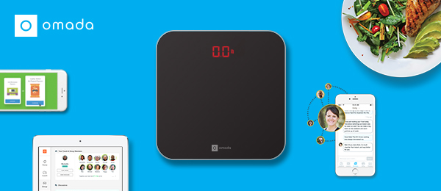
Hi team,
Say hello to a whole new way to get healthy!
I’m excited to announce that the Public Employees Benefits Board (PEBB) Program is now offering the Diabetes Prevention Program, powered by Omada®, to eligible employees and their adult family members enrolled in a PEBB medical plan. This digital lifestyle program can help you lose weight, feel fantastic, and develop long-term healthy habits.

More great news: If you or your adult family members are at risk for type 2 diabetes, your PEBB medical plan will cover the entire cost of the program.

Participants will get:
- A professional health coach to keep you on track
- A wireless smart scale to monitor your progress
- An interactive program with weekly lessons
- A supportive peer group and much more!

See if you’re eligible. I can’t wait to see what we accomplish!
Happy in health,
ADD YOUR CONTACT INFO
The PEBB Diabetes Prevention Program is powered by Omada.

END

MESSAGE 2

Subject: 3 reasons to try your new digital lifestyle benefit
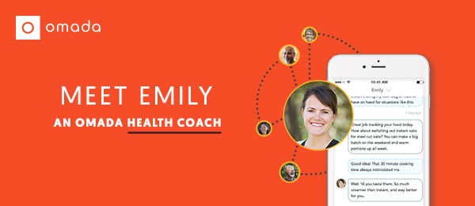
Hi team,
Check out our new digital lifestyle change program that helps combat obesity-related chronic diseases. I’ve had a chance to check it out, and wanted to share a few of my favorite parts about the program.
First, the health coach. The program includes your own professional coach (like Emily!) who is there to keep you on track—on your best days and your worst. They personalize the experience to ensure you’re getting exactly what you need to be successful.
Second, the tools and technology. Once you sign up, you’ll get a welcome kit delivered to your doorstep. It includes a wireless smart scale that’s automatically linked to your online account, making it easy (and addictive) to monitor your weight loss progress.
Last but not least: it actually works. You may have tried other programs or diets in the past. (Who hasn’t?) But the Diabetes Prevention Program powered by Omada is different. The average graduate continues to engage in the program and loses more than 10 pounds over 16 weeks.
But don’t take it from me…
Take a 1-minute risk screener today to find out if you’re eligible.
Happy in health,
ADD YOUR CONTACT INFO
The PEBB Diabetes Prevention Program is powered by Omada.
END

MESSAGE 3

Subject: Play the Don’t Buy the Baloney game
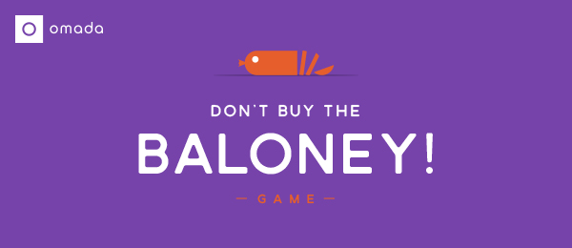
Hi team,
Food companies work hard to make their products seem healthy, even when they’re not. But a new Public Employees Benefits Board (PEBB) health benefit offered to eligible employees and their adult family members can help you navigate the grocery store like a pro.
Here’s an example, straight from the program. Play the Don’t Buy the Baloney game and find out which health food claims are actually full of it.
If you’d rather have fun than go on another crash diet, check out the Diabetes Prevention Program powered by Omada. Joining won’t cost you a thing, and you’ll learn to build healthy habits that actually stick.
See if you’re eligible by taking a 1-minute risk screener.
I’m rooting for you already,
ADD YOUR CONTACT INFO
The PEBB Diabetes Prevention Program is powered by Omada.

END

MESSAGE 4

Subject: Take 1 minute to prioritize yourself
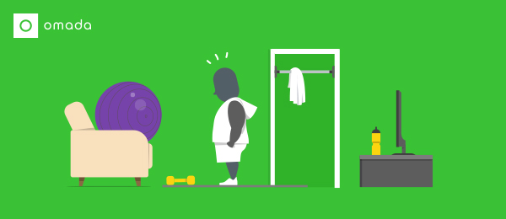
Hi team,
With work, kids, household obligations, and everything else you have going on, I know it’s sometimes hard to prioritize yourself. But every now and then, an opportunity comes around to be good to yourself. This is one of those times.
If there’s even a chance that you could be at-risk for obesity-related chronic diseases, I urge you to take this 1-minute risk screener now.
If you or your adult family members are at risk, the PEBB Diabetes Prevention Program powered by Omada could change your life. It inspires healthy habits you can live with long-term to help reduce your odds of developing heart disease and type 2 diabetes.
And it’s easier than you may think—for instance, fitness doesn’t have to be all about spandex and barbells. There are tons of little habits you can build into your day to boost your fitness level, no gym required.
Let’s do this!
ADD YOUR CONTACT INFO
The PEBB Diabetes Prevention Program is powered by Omada.

END

Sepah SC, Jiang L, Peters AL. Long-term outcomes of a web-based diabetes prevention program: 2-year results of a single-arm longitudinal study. J Med Internet Res. 2015;17(4):e92.

