Diabetes Prevention Program Messages (PEBB)

How to use
- Use the messages below to promote the diabetes prevention programs (DPP) your PEBB medical plan offers at no cost to you.
- The messages are ready to use as is or edit to make them work for your organization.
- If needed, finish by adding your contact information, logo, and more.

Tip: Highlight the value of worksite wellness by getting leadership to send the DPP messages. Doing this completes tasks 1.3 and 5.4 of our SmartHealth Worksite Wellness Roadmap to earn our annual Zo8 Award.

Email 1

Subject: Gain energy with the Diabetes Prevention Program powered by Omada

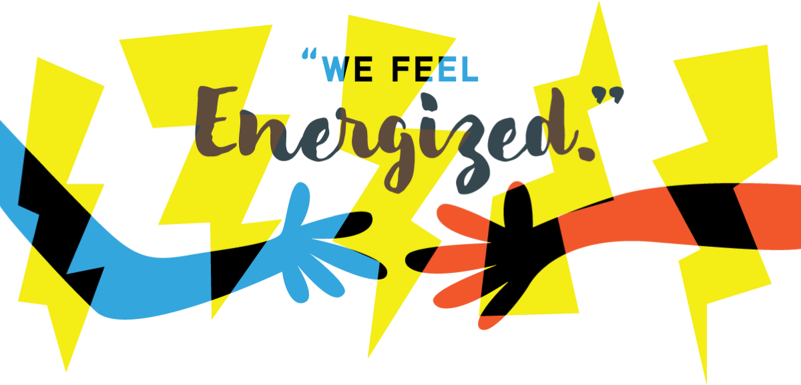

“I had a good feeling from the start, when I noticed the overall acceptance and non-judgmental nature. Everybody starts at their own point and has their own challenges, and Omada's focus is on improving from whatever the starting point. But it really hit home a couple weeks into the program, when I weighed in and checked my history. I already lost a couple pounds and felt more energetic. All without making any changes that I would want to cheat from or stop. Just long-term healthier changes that I can maintain for my own benefit. I’ve improved my eating, exercise, sleeping, responses to stress, and more. I'm now 16 weeks in and over 20 pounds down, with my eye on losing at least 10 more. And I feel confident that I can do it with what I already know.” – Olympia, WA

Join other PEBB members in the Diabetes Prevention Program powered by Omada®

If you’re ready to lose weight, gain energy, and improve your overall health, check out Omada.

Take a one-minute health screener to find out if you’re eligible.

The program is offered at no cost if you and your eligible adult dependents are enrolled in a PEBB medical plan and are at risk for type 2 diabetes.

This digital care program surrounds you with the tools and support you need to help reach your health goals, one step at a time.

If you’re already enrolled in the Diabetes Prevention Program powered by Omada—congrats! There’s no need to reapply.

The PEBB Diabetes Prevention Program is powered by Omada. Visit Diabetes prevention to learn more.

Testimonials are based on the participants’ real experiences using the Omada Program and are not necessarily representative of all persons who will use the program. They are based on individual results, and results may vary based on age, gender and other individual and demographic factors. Omada does not claim that they are typical results that participants will generally achieve.

Email 2

Subject: Reaching a health goal never felt so good

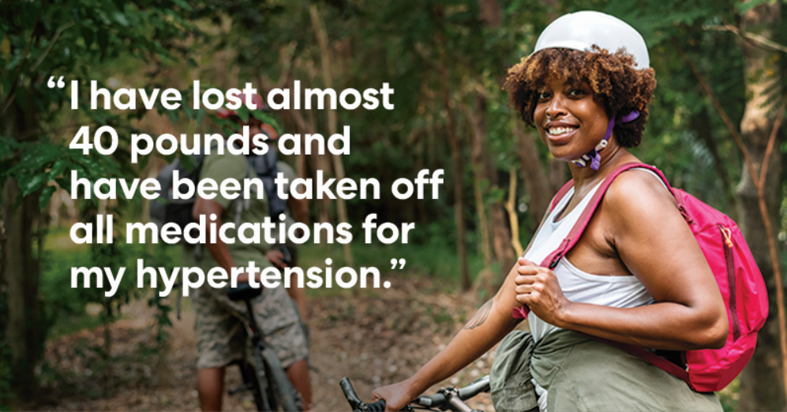

“After nearly four months of commitment to the program and its content, I have lost almost 40 pounds and have been taken off all medications for my hypertension. My recent Doctor's visit was an amazing turn around with him leaving the room shaking his head saying he never gets to tell his patients "not to take" the medications he had to put them on for high blood pressure. He was not aware of the Omada program and I must say he was very impressed when I briefly discussed the program, what it was about and how it worked. I realize the program would work for me by the end of the second week and my doctor got to see the results (affects) it has had on my health four months later. A win-win!” – Lacey, WA

Change your life in a big way

If you’re ready to make a few simple changes that could have a huge impact on your quality of life, check out the Diabetes Prevention Program powered by Omada®. This digital behavior change program can empower you in your fight against weight-related health issues and help reduce your risk of type 2 diabetes.

Many PEBB members have already joined Omada. To see if you’re eligible to join them, take a one-minute health screener.

Omada surrounds you with everything you need—including a health coach, wireless scale, online support program and peer group—to help you develop healthy habits that stick. Best of all, the program won’t cost you a thing. That’s right, the program is offered at no cost to you and your eligible adult dependents who are enrolled in a PEBB medical plan and are at risk for type 2 diabetes.

We hope you take this opportunity to do something wonderful for your future.

If you’re already enrolled in the Diabetes Prevention Program powered by Omada—congrats! There’s no need to reapply.

The PEBB Diabetes Prevention Program is powered by Omada. Visit Diabetes prevention to learn more.

Testimonials are based on the participants’ real experiences using the Omada Program and are not necessarily representative of all persons who will use the program. They are based on individual results, and results may vary based on age, gender and other individual and demographic factors. Omada does not claim that they are typical results that participants will generally achieve.

Email 3

Subject: Why the Diabetes Prevention Program powered by Omada clicked for Nick

“That voice you're hearing in your head, saying you're not sure or you don't think it would work for you? That's just the years of accumulated doubts from yourself and those around you talking. So here's a new voice: I was you and still am. I thought I'd give it some time, and end up right back where I started. But thanks to the daily weigh ins, the food tracking, the coaching, and the scale, I've had success at doing something that I've not had success with in 15 years - reversing my weight gain, feeling more fit, and knowing that I'm in this for the long haul. I've started thinking about my health in terms of years and years, not just 4-6 weeks at a time. It's just a few little things every day that make the big changes that are going to lower my risk of diabetes and heart disease. I still have doubts, I still hear those voices and doubters. But I also know I'm committed to doing those little things that are going to add up. And let me be perhaps the first voice to say to you, I think you can do it too. Take the survey and sign up.” – Mukilteo, WA

Do healthy your way

The Diabetes Prevention Program powered by Omada® is designed to fit seamlessly into your life. You can participate in online lessons, learn from a professional health coach, and be matched with a group of people who are going through the very same challenges you are. You can log in anytime, anywhere.

Many PEBB members have joined Omada to lose weight and gain healthy habits for life. See if you’re eligible to join them by taking a one-minute health screener.

The program is offered at no cost to you and your eligible adult dependents are enrolled in a PEBB medical plan and are at risk for type 2 diabetes.

If you’re already enrolled in the Diabetes Prevention Program powered by Omada—congrats! There’s no need to reapply.

The PEBB Diabetes Prevention Program is powered by Omada. Visit Diabetes prevention to learn more.

Testimonials are based on the participants’ real experiences using the Omada Program and are not necessarily representative of all persons who will use the program. They are based on individual results, and results may vary based on age, gender and other individual and demographic factors. Omada does not claim that they are typical results that participants will generally achieve.

