Diabetes Prevention Program Messages (SEBB)

How to use
- Use the messages below to promote the diabetes prevention programs (DPP) your SEBB medical plan offers at no cost to you.
- The messages are ready to use as is or edit to make them work for your organization.
- If needed, finish by adding your contact information, logo, and more.

Tip: Highlight the value of worksite wellness by getting leadership to send the DPP messages. Doing this completes tasks 1.3 and 5.4 of our SmartHealth Worksite Wellness Roadmap to earn our annual Zo8 Award.

Email 1

Subject: Gain energy with the Diabetes Prevention Program powered by Omada

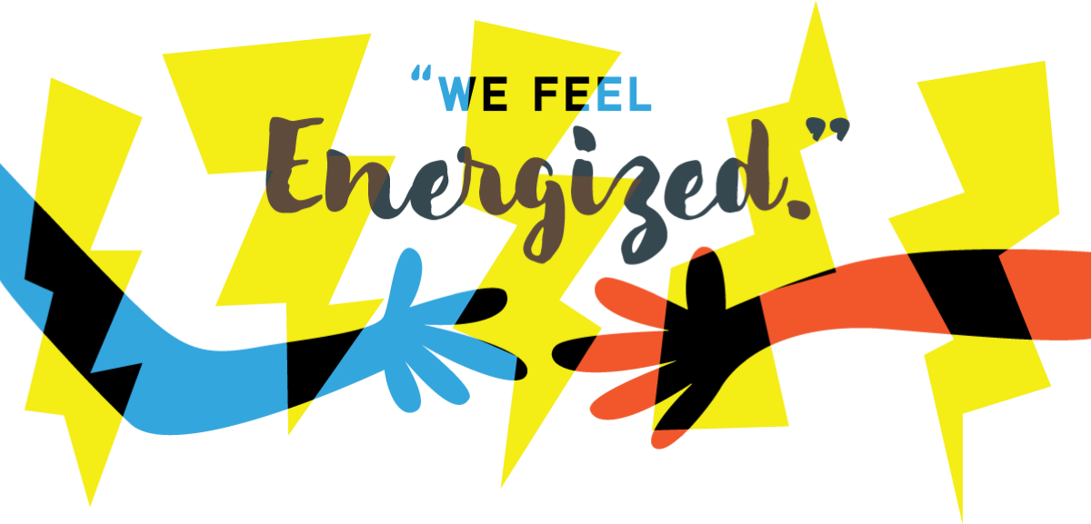

“I can tell you that since starting this program I am now sledding, chasing, swimming, and playing at the park with [my great granddaughter]. I have lost weight and my energy levels are great.” – Janet, 61

Join other SEBB members in the Diabetes Prevention Program powered by Omada®.

If you’re ready to lose weight, gain energy, and improve your overall health, check out the Diabetes Prevention Program powered by Omada.

Take a one-minute health screener to find out if you’re eligible,

If you or your adult family members are at risk for type 2 diabetes, your SEBB medical plan
will cover the entire cost of the program.

This digital care program surrounds you with the tools and support you need to help reach your health goals, one step at a time.

We can’t wait to see what else you can accomplish!

If you’re already enrolled in Omada—congrats! There’s no need to reapply.
The SEBB Diabetes Prevention Program is powered by Omada. It's available to SEBB members enrolled in Kaiser Permanente or UMP plans. Premera Blue Cross members have a different program available. Learn more at Diabetes Prevention.

Testimonials are based on the participants’ real experiences using the Omada Program and are not necessarily representative of all persons who will use the program. They are based on individual results, and results may vary based on age, gender and other individual and demographic factors. Omada does not claim that they are typical results that participants will generally achieve.

Email 2

Subject: Reaching a health goal never felt so good

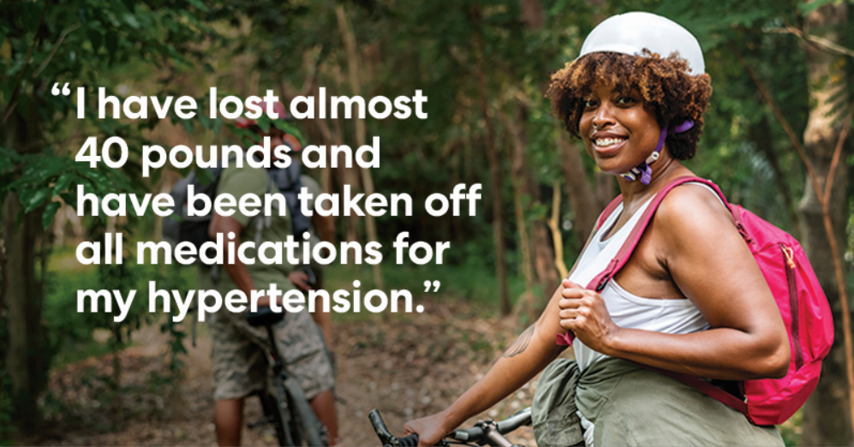

“I was losing some weight and the numbers were looking good, but when I got my blood work back from my doctor and he dropped my Metformin (prescription) in half, I knew that I was on to something. This encouraged me to stay focused and continue the path.” – Charlie, 58

Change your life in a big way.

If you’re ready to make a few simple changes that could have a huge impact on your quality of life, check out the Diabetes Prevention Program powered by Omada®. This digital behavior change program can empower you in your fight against weight-related health issues and help reduce your risk of type 2 diabetes.

Many SEBB members have already joined Omada. To see if you’re eligible to join them, take a one-minute health screener.

Omada surrounds you with everything you need—including a health coach, wireless scale, online support program and peer group—to help you develop healthy habits that stick. Best of all, the program won’t cost you a thing. That’s right, the program is offered at no cost to you and your eligible adult dependents who are enrolled in a SEBB medical plan and are at risk for type 2 diabetes.

We hope you take this opportunity to do something wonderful for your future.

If you’re already enrolled in Omada—congrats! There’s no need to reapply.

The SEBB Diabetes Prevention Program is powered by Omada. It's available to SEBB members enrolled in Kaiser Permanente or UMP plans. Premera Blue Cross members have a different program available. Learn more at hca.wa.gov/sebb-dpp.

Testimonials are based on the participants’ real experiences using the Omada Program and are not necessarily representative of all persons who will use the program. They are based on individual results, and results may vary based on age, gender and other individual and demographic factors. Omada does not claim that they are typical results that participants will generally achieve.

Email 3

Subject: Why the Diabetes Prevention Program powered by Omada clicked for Nick

“This is not a program that restricts or represses you in what you do in your daily life. You can be involved as much as you would like. The lessons are things that you may already know, but it is good reminders and check ups to keep you on track. I really liked that the coach suggested things to me and sent me information, before I really knew I needed it.” –Seattle, WA

I am sold on Omada. It has helped me to accomplish something that I have tried unsucessfully to accomplish for over 30 years. After severe injuries I needed some motivation to turn my life around and be more healthy. Omada found the motivating factor for me and it was the accountability and knowing that I had a coach when needed.

That voice you're hearing in your head, saying you're not sure or you don't think it would work for you? That's just the years of accumulated doubts from yourself and those around you talking. So here's a new voice: I was you and still am. I thought I'd give it some time, and end up right back where I started. But thanks to the daily weigh ins, the food tracking, the coaching, and the scale, I've had success at doing something that I've not had success with in 15 years - reversing my weight gain, feeling more fit, and knowing that I'm in this for the long haul. I've started thinking about my health in terms of years and years, not just 4-6 weeks at a time. It's just a few little things every day that make the big changes that are going to lower my risk of diabetes and heart disease. I still have doubts, I still hear those voices and doubters. But I also know I'm committed to doing those little things that are going to add up. And let me be perhaps the first voice to say to you, I think you can do it too. Take the survey and sign up.

Do healthy your way.

The Diabetes Prevention Program powered by Omada® is designed to fit seamlessly into your life. You can participate in online lessons, learn from a professional health coach, and be matched with a group of people who are going through the very same challenges you are. You can log in anytime, anywhere.

Many SEBB members have joined Omada to lose weight and gain healthy habits for life. See if you’re eligible to join them by taking a one-minute health screener.

The program is offered at no cost to you and your eligible adult dependents who are enrolled in a SEBB medical plan and are at risk for type 2 diabetes.

If you’re already enrolled in Omada—congrats! There’s no need to reapply.

The SEBB Diabetes Prevention Program is powered by Omada. It's available to SEBB members enrolled in Kaiser Permanente or UMP plans. Premera Blue Cross members have a different program available. Learn more at Diabetes prevention.

Testimonials are based on the participants’ real experiences using the Omada Program and are not necessarily representative of all persons who will use the program. They are based on individual results, and results may vary based on age, gender and other individual and demographic factors. Omada does not claim that they are typical results that participants will generally achieve.

