Diabetes Prevention Program Message (PEBB)

How to use
- Use the message below through June 30, 2022, to promote the diabetes prevention program (DPP) your PEBB medical plan offers at no cost to you.
- The message is ready to use as is or edit to make it work for your organization.
- If needed, finish by adding your contact information, logo, and more.

Tip: Highlight the value of worksite wellness by getting leadership to send the DPP message. Doing this completes tasks 1.3 and 5.4 of our SmartHealth Worksite Wellness Roadmap to earn our annual Zo8 Award.

MESSAGE BELOW

Subject line: Exercise that doesn’t feel like exercise
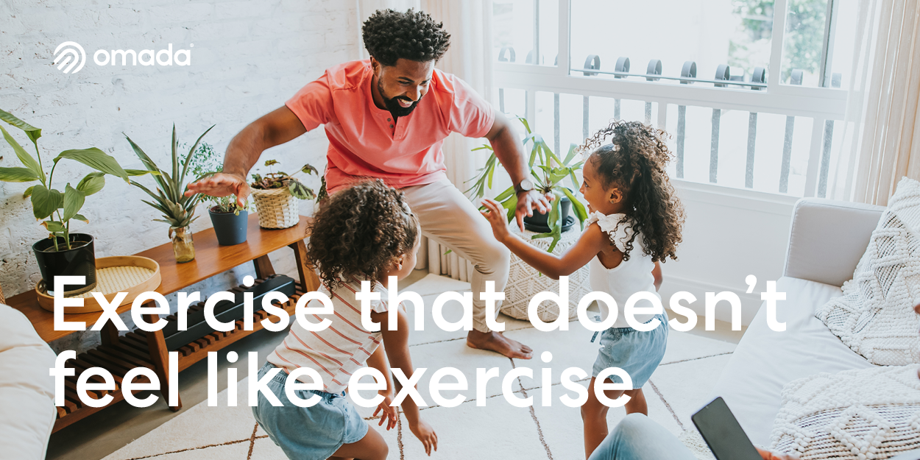

We could all move more throughout the day but making time for it can be downright challenging. We’ve got you covered! Hour by hour, here’s a list of ways to sneak more movement into your day.

6 a.m.: Cool off in the shower. The colder your shower, the more work your body is doing to heat itself. Every single goose bump you get is the action of a tiny muscle, and it counts.

​8 a.m.: Add a few steps to your commute. Taking the bus? Walk to a further stop before you hop on. Driving the whole way to work? Park at a spot farther away. A few minutes of walking can have big benefits.

9 a.m.: Create a dynamic workstation. Try getting into the habit of sitting on the edge of your chair (no slouching), crossing your legs (or just one) in your chair, or standing up.

10 a.m.: Take stretch breaks. Reach and stretch your arms overhead at least every 30 minutes or so.

Noon: Lunch outside anyone? Let your body experience the cold, the heat, the rain, and the snow. We’re accustomed to letting external tools regulate our temperature, but our body was the first central heating system!

2 p.m.: Give your eyes a screen break. Looking away from your screen helps you use the full range of motion of your eyes and can help maintain eye health.

6 p.m.: Chew your dinner. The jaw muscles are some of the most powerful in the body. Give your jaw a workout by swapping out processed foods, which tend to be softer than whole foods and veggies.

7 p.m.: Go for a walk after dinner. Take a walk around the block with the family, make it a date with a loved one, or go solo to reset from the day—it helps with digestion and helps the kids burn some energy before bed.

8 p.m.: Skip the couch during TV time and sit on the floor. It opens up your hips and lets your knees work at different angles.

The best part? You won’t need to do those things alone.
Whether you want to lose weight, eat better, move more, or have more energy, the Diabetes Prevention Program powered by Omada’s science-based approach helps you shift your mindset and change your health.
You’ll get a plan built around you, and the support of a dedicated health coach, weekly lessons, and a wireless smart scale — all at no cost to you.
It only takes a few minutes to get started.
Learn more about the program and find out if you’re eligible.

The PEBB Diabetes Prevention Program is powered by Omada. Visit Diabetes prevention to learn more.

