SmartHealth Custom Activity Request Form

INSTRUCTIONS

Contact your health promotion consultant as soon as possible to plan your custom activity.
- Enter information below
- At least 45 days ahead of your desired activity start date, email your completed request form to wawellness@hca.wa.gov or your Health Promotion Consultant.
  - Note: Development timeframes vary. More detailed challenges require more time to develop.

ENTER YOUR DETAILS
ORGANIZATION:
NAME:
PHONE:
EMAIL:

ENTER ACTIVITY DETAILS - See the next page for a KEY to help you fill out this form.
ACTIVITY TITLE | KEY area 1  40 Characters or less including spaces. | Enter the title of your Activity
ACTIVITY REQUIREMENT | KEY area 2  70 Characters or less including spaces. | What action do participants need to take to earn points?
DEVICE-ENABLED | Track with Fitbit or other tracking devices? | ☐ Yes  ☐ No
RECURRENCE DETAILS | How often will the activity occur? | ONE TIME
ACTIVITY DESCRIPTION | KEY area 3  2,000 Characters or less including spaces | Use this space to add more detail, provide context, tips, relevant links, etc. Make sure to provide all the information needed to complete the activity.
ACTIVITY DATES | KEY area 4 | Start date:  End date:
IMAGE | WebMD can select an image to use for the activity tile. | Any image you submit must meet the specifications for file type and dimensions: png or jpg file, less than 100 kb, 1144 x 166 pixels.

FOR WASHINGTON WELLNESS STAFF ONLY

TARGET GROUPS | Who should be eligible for this activity? Employee type, plan code(s), etc.
POINT VALUE | How many points per completion?
ACTIVITY TYPE | Is this a “Benefit Activity” or a “Featured Activity”?

Please use the key below to help you complete your request.
KEY
1 | Activity Title
2 | Activity Requirement
3 | Activity Description
4 | Activity End Date
5 | Points to be earned on completion (Washington Wellness to complete)
KEY area 4
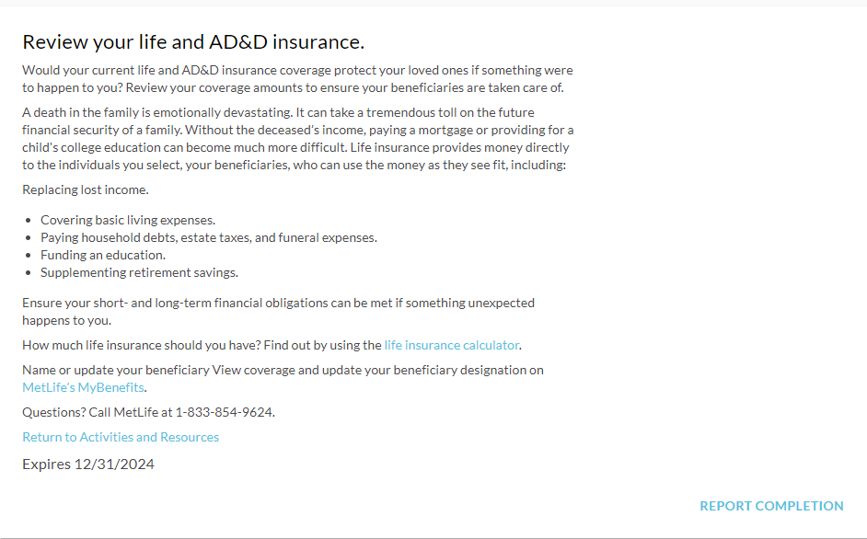
KEY Area 3
KEY Area 2
KEY Area 5
KEY Area 2
KEY Area 1

