**Omada logo**

**EMAIL COPY  
DISCOVER 2025**

The copy below is useful for employee emails, employee newsletters, and other company channels. The copy is also useful if introducing and supplementing the flyer and/or banner.

—--------------------------------------------------------------------------------------------------------------------------

**Title/Subject Line:** **Get support with the diabetes management program**



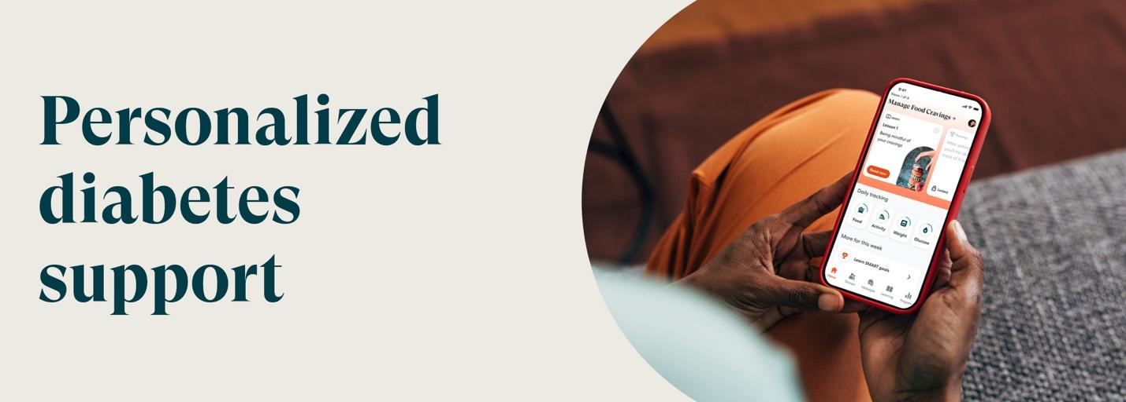

Join the SEBB Program’s diabetes management program powered by Omada today.

[**Check if you’re eligible**](http://www.omadahealth.com/wasebb/)

**Your welcome kit includes\***

Easy-to-use smart devices, delivered straight to your door—yours to keep:

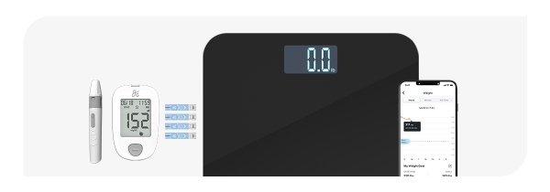

* Blood glucose meter (BGM)
* Ongoing supply of test strips and lancets
* Smart scale

If you or your adult family members are living with diabetes and are enrolled in a Uniform Medical Plan (UMP) plan, your plan will cover the cost of the program. This may include a connected glucose meter with as many test strips as you need and a digital scale—all yours to keep.

*The SEBB diabetes management program powered by Omada is available to SEBB UMP members. To learn about the diabetes management programs for Premera and Kaiser members, see* [*https://www.hca.wa.gov/sebb-diabetes*](https://www.hca.wa.gov/sebb-diabetes)*.*

**Disclaimers**

*Certain features and smart devices are only available if you meet program and clinical eligibility requirements.

Images, including apps, do not reflect real members or information about a specific person.

—--------------------------------------------------------------------------------------------------------------------------