**Omada**

**EMAIL COPY  
DISCOVER 2025**

The copy below is useful for employee emails, employee newsletters, and other company channels. The copy is also useful if introducing and supplementing the flyer and/or banner.

—--------------------------------------------------------------------------------------------------------------------------

**Title/Subject Line:** **The SEBB Program offers a personalized diabetes prevention program** 



The PEBB Program offers an easy-to-follow diabetes prevention program (DPP) powered by Omada.

Help lower your health risks and feel better with help from a health coach, a smart scale, and more.

[**Check to see if you are eligible**](http://www.omadahealth.com/wasebb)

**You’ll receive a digital smart scale**, delivered straight to your door and yours to keep:

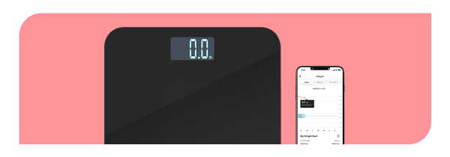

• No setup or WiFi is needed

• Automatically syncs to your private account

• Track your progress in real-time using the Omada app

The DPP is an easy-to-follow program and is personalized for you. Once you join, you’ll get:

* **Health coaching**. Get one-on-one support around nutrition, exercise, sleep, and stress.
* **Program personalized to you**. Choose what to focus on based on your health goals.
* **New lessons each week**. Activities to help build healthy habits.
* **Tools for managing stress**. To help with a healthy mindset.

If you or your adult family members are at risk for type 2 diabetes, your SEBB medical plan will cover the entire cost of the program.

*The SEBB diabetes prevention program powered by Omada is available to SEBB members enrolled in Kaiser Permanente or Uniform Medical Plan (UMP) plans. Premera Blue Cross members have a different program available. Omada also offers a diabetes management program for SEBB members enrolled in UMP. To learn more about these programs, visit* [*Diabetes programs*](http://www.hca.wa.gov/sebb-diabetes)*.*

**Disclaimers**

Images, including apps, do not reflect real members or information about a specific person.

—--------------------------------------------------------------------------------------------------------------------------