**Omada logo**

**EMAIL COPY  
DISCOVER 2025**

The copy below is useful for employee emails, employee newsletters, and other company channels. The copy is also useful if introducing and supplementing the flyer and/or banner.

—-------------------------------------------------------------------------------------------------------------------------- **Subject Line: Gift yourself wellness for the holidays**



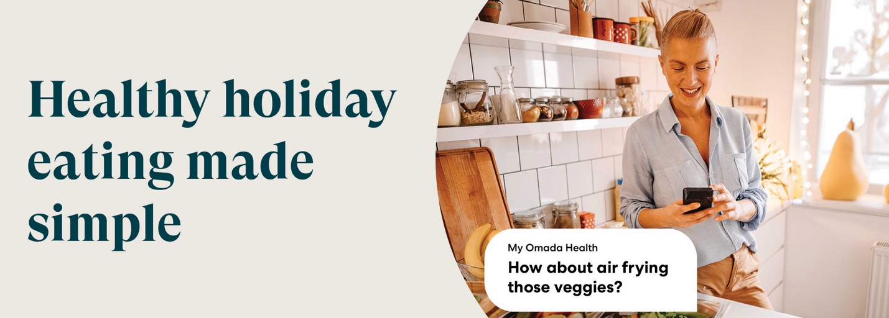

The SEBB Program offers a diabetes management program powered by Omada® that can help you navigate the holiday season. A health coach and diabetes specialist can help ease the stress of preparing festive meals with recipes that are both delicious and healthy. You also get support to help keep blood glucose in control while enjoying the holidays.

The best part? It’s fully covered by your medical plan.

**Get personalized health support from anywhere**

* **No restrictions**

No counting calories or restricting foods.

* **Dedicated care team**

One-on-one support from a health coach and diabetes specialist.

* **A plan built for you**

Advice and lessons tailored to each member.

**Your welcome kit includes\***

Easy-to-use smart devices. Shipped to your door, yours to keep.

* Blood glucose meter and ongoing test strip supply
* Smart scale

[**Check if you’re eligible**](http://www.omadahealth.com/wasebb)

If you or your adult family members are living with diabetes and are enrolled in a Uniform Medical Plan (UMP) plan, your plan will cover the cost of the program. This may include a connected glucose meter with as many test strips as you need and a digital scale—all yours to keep.

*The SEBB diabetes management program powered by Omada is available to SEBB UMP members. To learn about the diabetes management programs for Premera and Kaiser members, see* [*https://www.hca.wa.gov/sebb-diabetes*](https://www.hca.wa.gov/sebb-diabetes)*.*

**Disclaimers**

*Certain features and smart devices are only available if you meet program and clinical eligibility requirements.

Images, including apps, do not reflect real members or information about a specific person.

—--------------------------------------------------------------------------------------------------------------------------