**Omada logo**

**EMAIL COPY  
DISCOVER 2025**

The copy below is useful for employee emails, employee newsletters, and other company channels. The copy is also useful if introducing and supplementing the flyer and/or banner.

—-------------------------------------------------------------------------------------------------------------------------- **Title/Subject Line:** **Unwrap better health this holiday season**



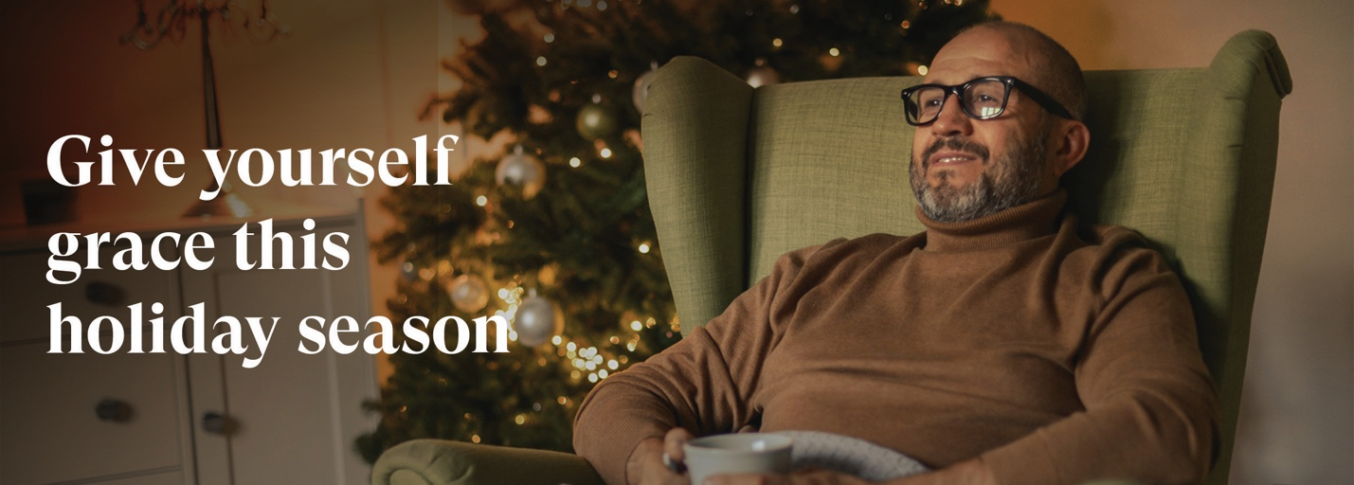

Staying healthy during the holidays can be overwhelming. The PEBB Program offers a diabetes management program powered by Omada® that can help..

Whether it's managing diabetes with less stress or improving overall health, your health coach and diabetes specialist can help make it your healthiest holiday yet.

**Your welcome kit includes:**

Smart devices that easily sync to the Omada app, delivered straight to your door.

* **Blood glucose meter and test strips**

Keep monitoring regularly with an ongoing supply of test strips and lancets.

* **Smart scale**

Track your progress with ease.

**Get support managing your diabetes this holiday season with:**

* A dedicated care team
* A personalized plan
* A quick and easy start

[**Check if you’re eligible**](http://www.omadahealth.com/wasebb)

If you or your adult family members are living with diabetes and are enrolled in a Uniform Medical Plan (UMP) plan, your plan will cover the cost of the program. This may include a connected glucose meter with as many test strips as you need and a digital scale—all yours to keep.

*The SEBB diabetes management program powered by Omada is available to SEBB UMP members. To learn about the diabetes management programs for Premera and Kaiser members, see* [*https://www.hca.wa.gov/sebb-diabetes*](https://www.hca.wa.gov/sebb-diabetes)*.*

**Disclaimers**

*Certain features and smart devices are only available if you meet program and clinical eligibility requirements.

Images, including apps, do not reflect real members or information about a specific person..

—--------------------------------------------------------------------------------------------------------------------------