**EMAIL COPY  
DISCOVER 2025**

The copy below is useful for employee emails, employee newsletters, and other company channels. The copy is also useful if introducing and supplementing the flyer and/or banner.

—--------------------------------------------------------------------------------------------------------------------------

**Title/Subject Line:** **Get support with the diabetes management program**



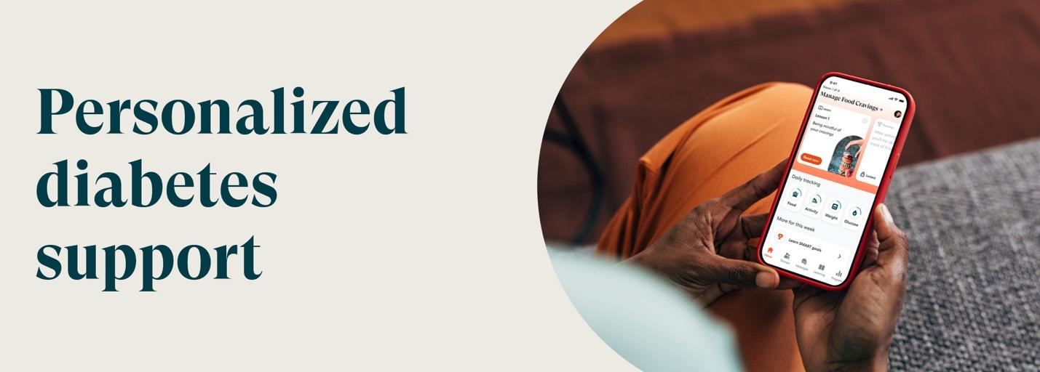

Join the PEBB Program’s diabetes management program powered by Omada today.

[**Check if you’re eligible**](http://www.omadahealth.com/wapebb)

**Your welcome kit includes\***

Easy-to-use smart devices, delivered straight to your door—yours to keep:

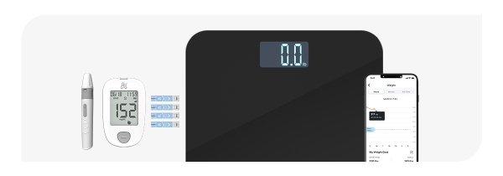

* Blood glucose meter (BGM)
* Ongoing supply of test strips and lancets
* Smart scale

If you or your adult family members are living with diabetes and are enrolled in Uniform Medical Plan (UMP), it will cover the cost of the program. This may include a connected glucose meter with as many test strips as you need and a digital scale—all yours to keep.

*The PEBB diabetes management program powered by Omada is available to PEBB UMP members. To learn more about the diabetes management programs for Kaiser members, visit* [*Diabetes programs*](http://www.hca.wa.gov/pebb-diabetes).

**Disclaimers**

*Certain features and smart devices are only available if you meet program and clinical eligibility requirements.

Images, including apps, do not reflect real members or information about a specific person.

—--------------------------------------------------------------------------------------------------------------------------