**EMAIL COPY  
DISCOVER 2025**

The copy below is useful for employee emails, employee newsletters, and other company channels. The copy is also useful if introducing and supplementing the flyer and/or banner.

—--------------------------------------------------------------------------------------------------------------------------

**Title/Subject Line:** The PEBB Program offers a personalized diabetes management program



Get stated with smart devices like a blood glucose meter and a pen



The PEBB Program offers an easy-to-follow diabetes management program powered by Omada.

Help build habits for better glucose control with help from a health coach and diabetes specialist, and smart devices.

[**Check if you’re eligible**](http://www.omadahealth.com/wapebb)

**You’ll receive**

a digital smart scale, delivered straight to your door and yours to keep.

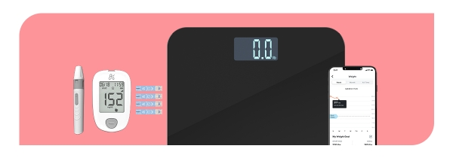

* Blood glucose meter (BGM)
* Ongoing supply of test strips and lancets
* Digital smart scale

Members can also use their current BGM.

The DMP is an easy-to-follow program and is personalized for you. Once you join, you’ll get:

* **Health coaching**. Get one-on-one support around nutrition, exercise, sleep, and stress.
* **Program personalized to you**. Choose what to focus on based on your health goals.
* **Certified diabetes specialist**. Get support to help monitor your blood glucose levels
* **No-cost diabetes supplies**. Get test strips and lancets shipped to your door.

If you or your adult family members are living with diabetes and are enrolled in Uniform Medical Plan (UMP), it will cover the cost of the program. This may include a blood glucose meter with as many test strips as you need and a digital smart scale—all yours to keep.

*The PEBB diabetes management program powered by Omada is available to PEBB UMP members. To learn more about the diabetes management programs for Kaiser members, see* [*http://www.hca.wa.gov/pebb-diabetes*](http://www.hca.wa.gov/pebb-diabetes).

**Disclaimers**

Certain features and smart devices are only available if you meet program and clinical eligibility requirements.

Images, including apps, do not reflect real members or information about a specific person.