Quarterly Claiming Quick Reference Guide for Salary Uploads

RMTS Pool Report
The RMTS Pool Report is a list of participants who were eligible for inclusion for that quarter. This list of participants will be used to create an editable template to upload with salary and benefit data into the claiming application.
Step 1: Under the Administrative Claiming tab, select Reports. Under the Random Moment Time Study Reports heading select the RMTS Pool Report.
Step 2: Using the drop-down menus, select Year and Quarter. Year and Quarter are based on fiscal year.
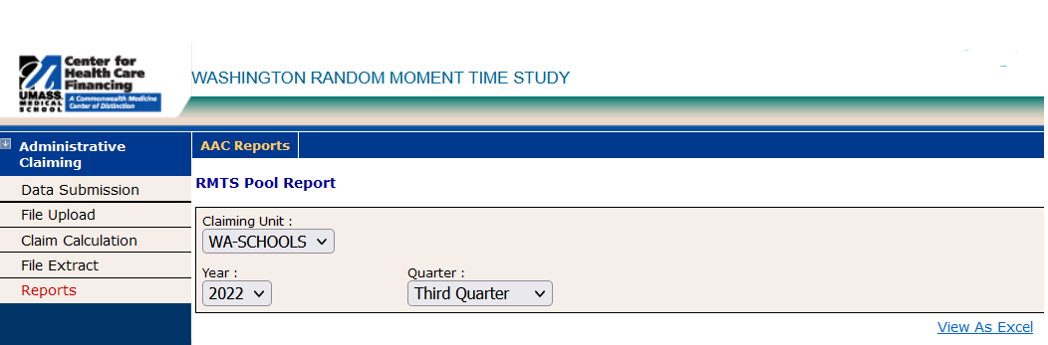
Step 3: Select the View as Excel link. The file can be opened or saved in Excel.
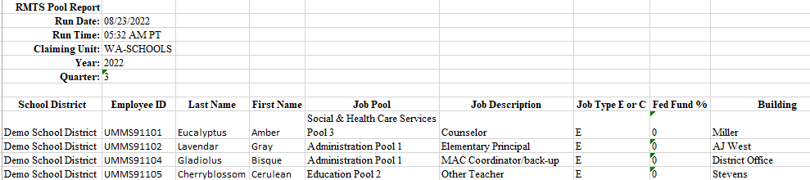

xxxCreating an Upload File Using THe RMTS Pool Report
Step 1: Copy and paste the Employee ID, Last Name, First Name, Job Description and Federal Funding % from the RMTS Pool report into the Salary Upload Template.
Step 2: Enter the value of Y or N in the Active Yes or No column
Step 3: Enter the Salary and Employer Paid Benefits
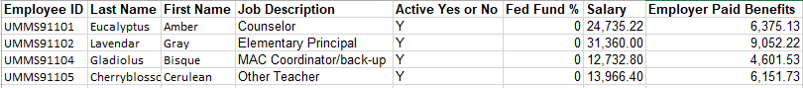

Step 4: Save the file as an ‘Excel 97-2003 Workbook’ file on your local PC or network. When saving the file to upload, the naming convention is: HP_CC_state_VendorID_Qtr_Year_Version#.xls.
Example: FY2022 Q3 = HP_CC_WA-SCHOOLS_123456_3_2022_01.xls 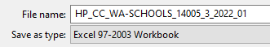

Uploading Files
Step 1: Under the “Administrative Claiming” tab, select “File Upload”. Click on “Year” to change the fiscal year if needed.
Step 2: Select “Participant CC” under component. Click “Browse” to find your file. Click “Open.”
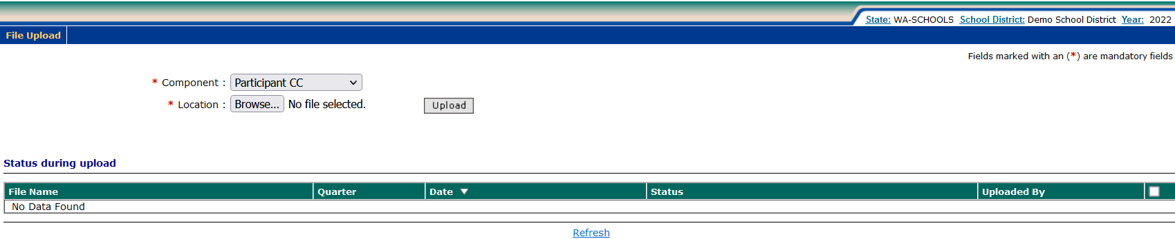
Step 3: Click “Upload.” The file will show up on the uploaded list below and will take some time before it is ready to be checked. You will need to click “Refresh” after a few minutes for the file status to change from Preview Queue to Review.
Step 4: Once the file is in Review status, click on the Review link to view any updates.
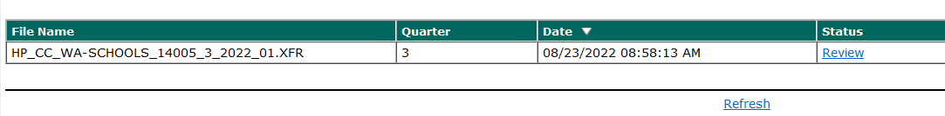

Note: If your file has errors, you will need to click on “Error” and then “View Detailed Report” to review the issues that caused the file to fail. Once you have fixed the problems in the file, delete the Error file by checking the box next to the file and clicking “Delete.” Then upload the corrected file.
Step 5: Review the available ‘Change Reports’; New Participant, Deactivated Participant, and Updates by clicking on the appropriate “View Detailed Report” link. If changes need to be made to the file, the file will need to be deleted and re-uploaded and checked again.
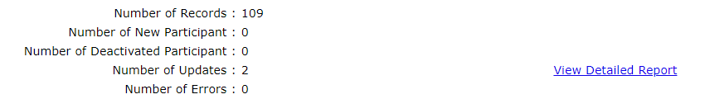
Step 6: Once everything is correct, check the “Verified Upload File Results” box and click “Upload” to upload the file.
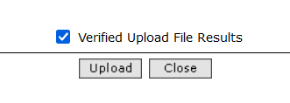

Note: Changes and additions in the file will not be made to the system until this step has been completed.
Step 7: When the file is submitted and uploaded, the status will change to “Successful” when completed. You will need to click “Refresh” after a few minutes for the file status to change. You may review the detailed reports at any time by clicking “Successful” and “View Detailed Report.”

