Tooth Chart | DATE
 | CLIENT’S NAME
 | CLIENT’S ID NUMBER
DENTIST/DENTURIST’S NAME | DENTIST/DENTURIST’S PHONE NUMBER (with Area Code)
PROVIDER NPI NUMBER | PROVIDER FAX NUMBER
Have all dental and periodontal services been completed on all remaining teeth? Yes ____ No ____
If not, please submit treatment plan and periodontal chart.
Mark the chart below
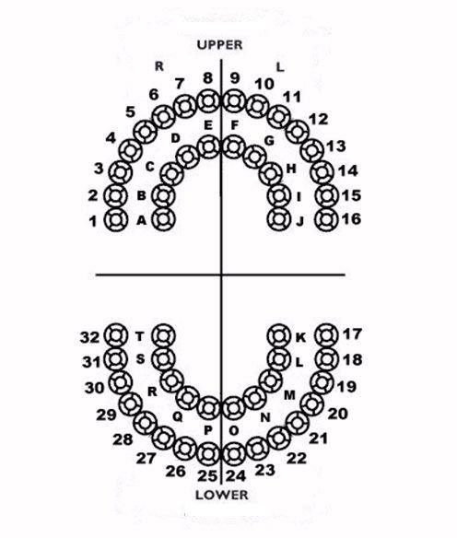
HCA 13-863 (2/15)

