Diabetes Prevention Program Reminder Message
Use the customizable message below for your follow-up outreach of your testing event wherever you promote wellness (such as email or intranet). Copy and paste the message and add your information to finish customizing.

What do I customize?
Change the following sections to customize your message.
- Blue “Make an appointment” box
  - Insert the date, time, and location of your testing event.
- Organization logo
  - Replace the Washington State Health Care Authority logo with yours.

Email subject (if needed)
Reminder! Diabetes screening – what's your risk?

Message

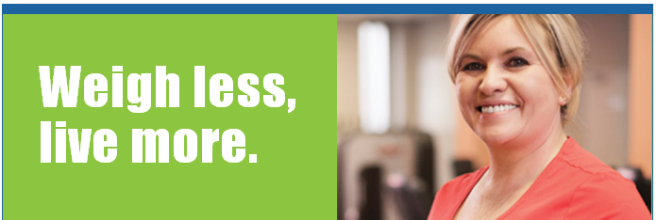
It’s not too late – register today!
<Month DD, YYYY>  <00:00 am/pm – 00:00 am/pm> | <Location/Building> <Room>  <Street Address>  <City>, <State> <ZIP>

Attend the upcoming screening event to learn your risk of type 2 diabetes. If you qualify, there may be a program to help you lose weight and prevent diabetes. And best of all, you can participate at NO COST as part of your health plan.*
What’s your score? If you score 9 or higher, call today!

You will receive:
- 16 weekly health coaching sessions.
- Support to track progress, learn healthy eating habits, and reduce stress.

Please bring your health plan ID card and allow 15 minutes for the appointment.

Can’t make the event? No problem.
Call 1-888-926-6099 Ext. 326
for more information and to enroll.

1 New England Journal of Medicine, Vol. 346, No. 6 (2002)

*The Diabetes Prevention Program (“DPP”) is available to you at no additional cost as part of your health plan.
Participation in the DPP is completely voluntary. Your personal health information is kept private in accordance with your health plan’s privacy policy and applicable law.

The contents of this email are solely the responsibility of the authors and have not been approved by the Department of Health
and Human Services, Centers for Disease Control and Prevention. This project is partially funded with 2012 Prevention and Public Health funds through a federal grant (Grant Number 1U58DP004-176-01) from the Department of Health and Human Services, Centers for Disease Control and Prevention.

