Diabetes Prevention Program Introduction Message
Use the customizable message below for your initial outreach of your testing event wherever you promote wellness (such as email or intranet). Copy and paste the message and add your information to finish customizing.

What do I customize?
Change the following sections to customize your message.
- Blue “Make an appointment” box
  - Insert the date, time, and location of your testing event.
- Organization logo
  - Replace the Washington State Health Care Authority logo with yours.

Email subject (if needed)
Diabetes screening – what's your risk?

Message

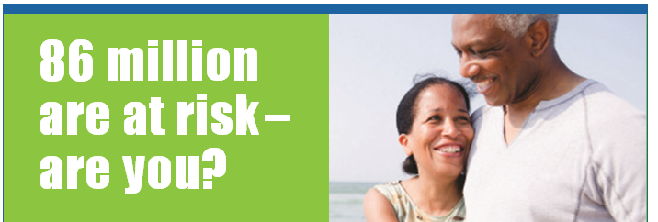
Attend the screening event and learn your
risk for developing type 2 diabetes.
<Month DD, YYYY>  <00:00 am/pm – 00:00 am/pm> | <Location/Building> <Room>  <Street Address>  <City>, <State> <ZIP>

One out of three Americans is at risk for type 2 diabetes.¹ We’re excited to offer you an easy way to help lose weight and reduce risk of developing type 2 diabetes. And best of all, you can participate at NO COST to you as part of your health plan.*
What’s your score? If you score 9 or higher, call today!

You will receive:
- 16 weekly health coaching sessions.
- Support to track progress, learn healthy eating habits, and reduce stress.

Please bring your health plan ID card and allow 15 minutes for the appointment.

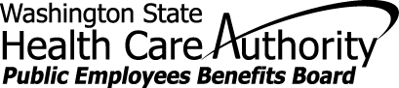
Can’t make the event? No problem.
Call 1-888-926-6099 Ext. 326
for more information and to enroll.

1 Centers for Disease Control and Prevention - 2014 National Diabetes Fact Sheet

*The Diabetes Prevention Program (“DPP”) is available to you at no additional cost as part of your health plan.
Participation in the DPP is completely voluntary. Your personal health information is kept private in accordance with your
health plan’s privacy policy and applicable law.

The contents of this email are solely the responsibility of the authors and have not been approved by the Department of Health
and Human Services, Centers for Disease Control and Prevention. This project is partially funded with 2012 Prevention and
Public Health funds through a federal grant (Grant Number 1U58DP004-176-01) from the Department of Health and Human
Services, Centers for Disease Control and Prevention.

