EMAIL COPY - “I DON’T HAVE TIME” (Global Employee Health / Fitness)
Title/Subject Line: “I don’t have time” (says almost everyone)
Subtitle/Preheader: Just 10 minutes of exercise can make all the difference. Get support through the Diabetes Prevention Program powered by Omada.
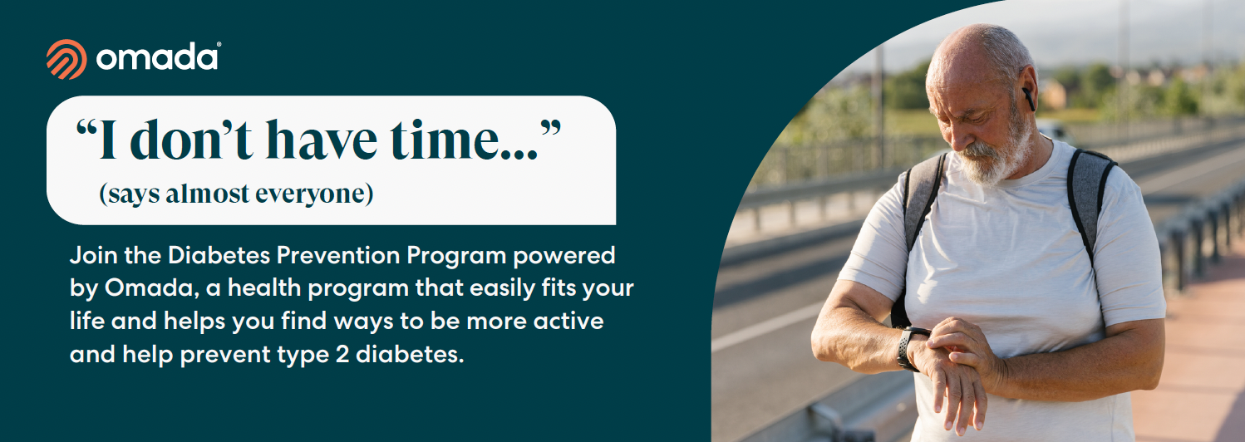

Being busy can be stressful and most people will put exercise at the bottom of their to-do list. Luckily, starting an exercise habit doesn’t take much time. Exercising just 10 minutes a day can help your heart, health, and mood, and it can help prevent type 2 diabetes.

With the Diabetes Prevention Program powered by Omada, you get a program that easily fits your life and helps you find ways – and time – to be more active.

Beat the excuses.
- “I don’t have time...” You only need 10 minutes a day. On average, Omada members engage in their exercise program 1 to 2 hours each week.
- “I don’t know where to start...” Your coach has your back. They’ll point you in the right direction with an exercise plan tailored to fit your life.
- “I don’t like the gym...” A gym can help but you can do a lot at home. We’ll show you how to add more physical activity into your daily routines.

From an Omada member: “Little by little my motivation began to increase as I saw the differences it was making.
I felt more energy.”

Check if you’re eligible

The PEBB Diabetes Prevention Program is powered by Omada. ​Learn more at Diabetes prevention.

