EMAIL COPY - “FOR YOUR LOVED ONES”

Title/Subject Line: Hey man...your health is too important.
Subtitle/Preheader: Help prevent type 2 diabetes and improve your health for your family, and yourself.
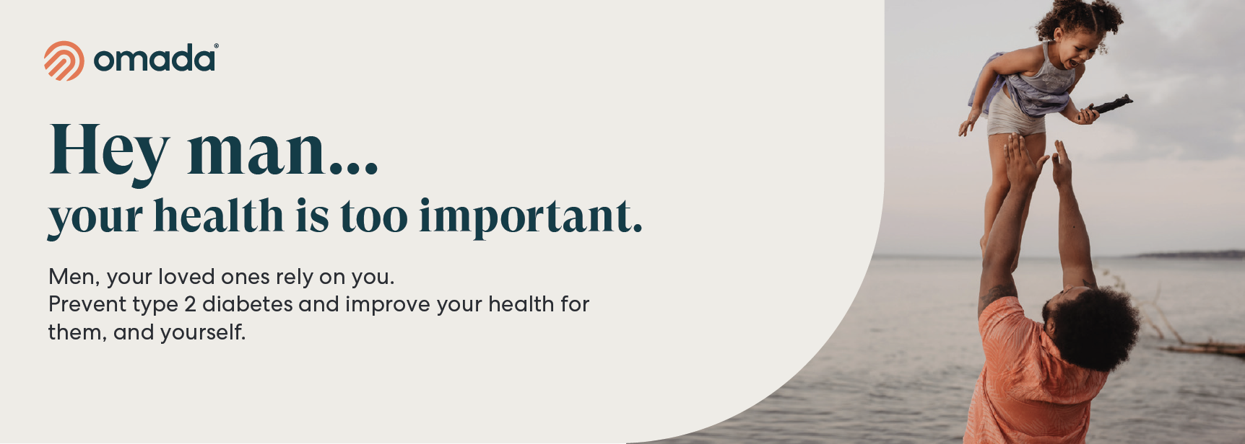
Over 1 in 3 men are at risk for type 2 diabetes, which is a serious health condition, but it can be managed. Ignoring your health can add emotional stress for those who care about you.
The Diabetes Prevention Program powered by Omada can help. You get private and personal care to help improve your health in small ways that work best for you. Use it anytime, anywhere.

Support personalized for you:

- A personal health coach gives you one-on-one support.
- Get healthy with foods you already enjoy.
- On your time. If you have a smartphone, you have your health coach.
- Tools to guide you. Smart scale to track your progress (yours to keep).
- Made for you. A wellness plan and lessons tailored to your goals and lifestyle.
The program is excellent and really helps you think about nutrition, healthy eating and physical fitness in a whole new light. The program is outstanding!” — Omada Member
Check if you’re eligible

The PEBB Diabetes Prevention Program is powered by Omada. ​Learn more at Diabetes prevention.

