EMAIL COPY - “OVERCOME STRESS ONE BREATH AT A TIME”
Title or Email Subject Line:
Overcome stress one breath at a time with the Diabetes Prevention Program powered by Omada
Subtitle or Email Preheader:
Breathe easier and stress less with the Diabetes Prevention Program powered by Omada
Overcome stress one breath at a time
Use deeper breathing to reduce stress and feel better.

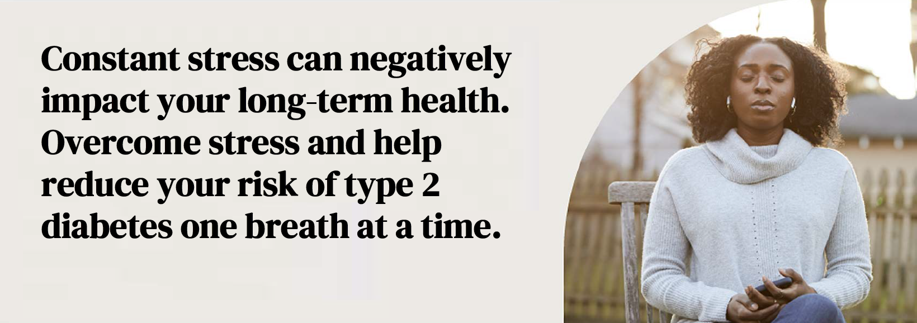

Studies show that practicing deep, controlled breathing slows your heart rate and can calm your feelings to help reduce stress and depression. It even helps to increase alertness, improve sleep, and boost your immune system.

With the Diabetes Prevention Program powered by Omada, you’ll have help to breathe more, breathe better, improve your overall health, and help reduce your risk for type 2 diabetes.

5 steps to deeper breathing:
- Relax your body. Find somewhere to sit or lie down comfortably.
- Close your eyes and inhale slowly through your nose. Feel your breath as it causes your belly to expand.
- At the end of your inhale, pause for a few seconds, then exhale fully through your mouth.
- Focus on each breath as it goes in and out of your body.
- If your attention wanders, that’s okay. Bring the focus back to your next breath.

“I love having Omada in my corner...I am learning to eat, move and breathe... I am unstuck. I see beauty again.”
- Omada member

Breathe a little easier with the Diabetes Prevention Program powered by Omada.

Check if you’re eligible

The PEBB Diabetes Prevention Program is powered by Omada. ​Learn more at Diabetes prevention.

